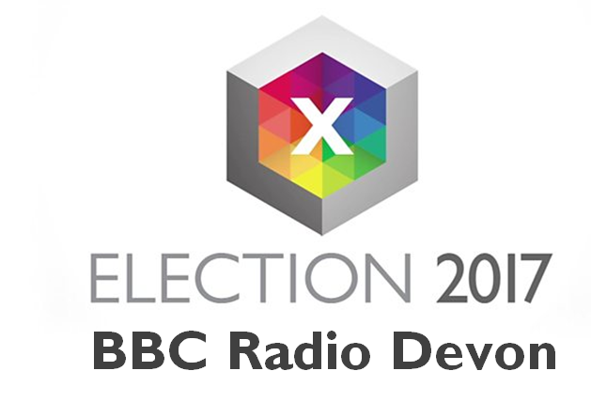

Be in the audience at BBC Radio Devon’s General Election Debate

24th May 6.30pm

Sandy Park Exeter

Everyone applying to be part of the BBC Radio Devon audience is required to complete this form. The information is completely confidential and used only by the BBC Radio Devon team for the purpose of balance.
The audience is a key factor in the programme and moves the debates forward; we welcome your questions and have included a section in this questionnaire asking what topics that you would like to discuss and subsequently to provide two questions. The debate will be around an hour long and we may not have the time to fit in every question.

Due to the volume of requests received we apologise that we are unable to include everyone in the audience. If you hear nothing from us please assume that on this occasion your application has not been successful.
Please ensure your application has been returned to devonelection@bbc.co.uk by 21st May 2017. *indicates mandatory fields
*Full name:

*Your address, including postcode:

*Daytime phone number:

Evening phone number:

Mobile phone number:

*Email address:

*Do you wish to ask a question? If so, please could you complete the next two questions, if not please move on to the question about age.

*What is the FIRST topical issue you would like to discuss?

*What is the SECOND topical issue you would like to discuss?

*How old are you?
- Under 18
- 18-24
- 25-34
- 35-44
- 45-54
- 55-64
- 65+
*What is your gender?

*What is your occupation? (If retired, what was your profession before retirement?)

*To which ethnic group do you belong?

*Do you consider yourself to have any disabilities?
Do you require wheelchair access?

*Do you know how you are planning to vote in the General Election?

*Which political party would you be most likely to vote for?

How did you vote at the last General Election?

How did you vote in the EU Referendum?

Political party membership **

Are you active in any campaign groups?

If yes, what is the campaign?

Everyone wishing to be part of the BBC Radio Devon’s audience needs to complete the above questionnaire. If any of your friends or family has applied please supply their names and telephone numbers/email addresses so we can make contact to discuss their details.

**This information will be collected by the BBC and shared with producers of BBC Radio Devon’s election debate for this election only.

BBC Radio Devon will have full editorial control of the debate.

The BBC promises that you will not receive unsolicited mail by supplying your personal details. The BBC and any service provider we engage will use the information you supply to respond to your queries or comments, to develop and enhance our services and for statistical analysis of audiences and users. For full details of our policy regarding the personal information we collect about you visit our Privacy and Cookies page. All personal information supplied is held securely by the BBC and in accordance with the Data Protection Act 1998. Your details will not be used for any other service.

