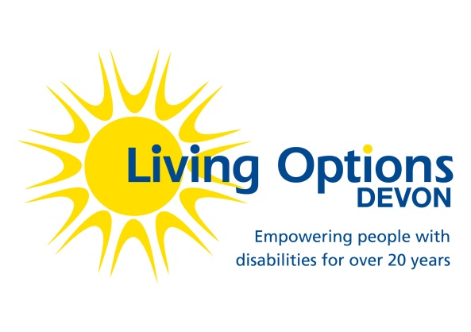  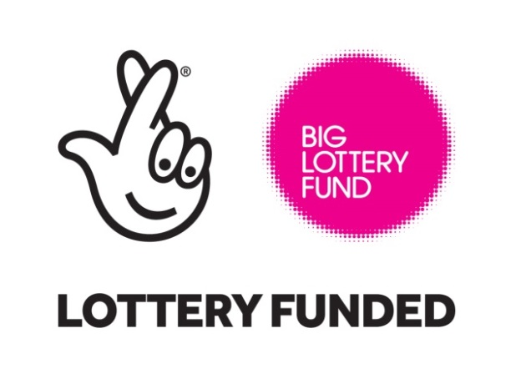  Sunday 16th JULY  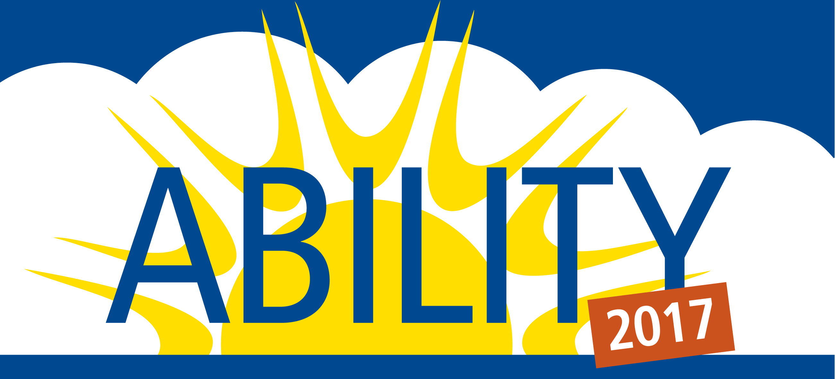  FREE Family Festival  For further details, please contact:  Keira Dodd Office Coordinator, Living Options Devon  Tel: 01392 459222 SMS: 07958 517919  www.livingoptions.org keira.dodd@livingoptions.org  All donations from exhibitors will be used directly to help fund this event. | On the 16th of July 2017, Living Options Devon (LOD) will be hosting a free family festival in Northernhay Gardens, Exeter in celebration of people with disabilities and Deaf people within the community.  ────  Planned to coincide with Disability Awareness Day 2017 - based around a marquee with workshops and demonstrations of accessible arts and sports for all the family - also stalls promoting LOD and other local charities!  ────  We will be advertising this event widely through our members, partner organisations and local and regional media  ────  You are invited to exhibit at our event.  PLACES ARE LIMITED, SO PLEASE RESERVE YOURS AS SOON AS POSSIBLE!

